Log in to PeopleSoft Finance (see link below).

You will use the same UserID (employee ID number) and password you’re currently using for the other PeopleSoft systems.

https://finance.williams.edu/psp/fs92prd/?cmd=login

Follow this navigation: Main Menu – Main Menu (again) – WMS Financial Reports.

Below is a screenshot of how to fill out the screen.
Enter this Fiscal Year (2019).
Then enter a Project number (6 digits) or department number (7 digits) and click on Search for Reports.

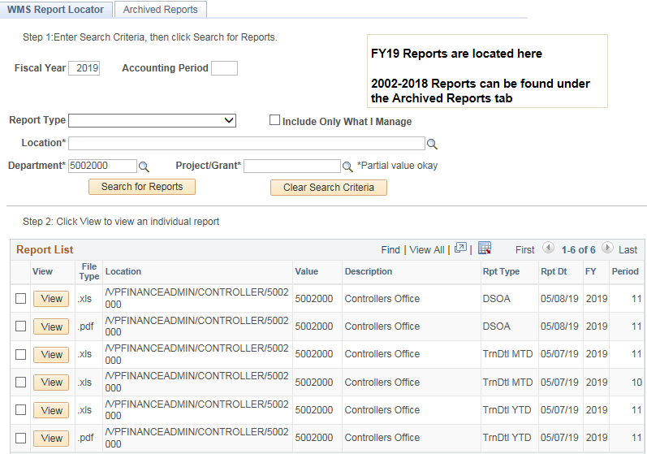

You will see multiple reports.
The first two reports are usually the summary reports (SOA’s) which offer a snapshot of all spending for the current Fiscal Year (2019). The pdf version is already formatted to print. Sometimes the first report is the miscellaneous report.
Open this report (either a DSOA or a PSOA) depending whether you entered a Project # (PSOA) or Department # (DSOA) by checking the box and selecting “View.”
You can also access transaction detail reports (month-to-date or year-to-date). The pdf version of the YTD (year-to-date) transaction detail report is already formatted to print.
If you enter no dept or project numbers, you can usually see the overall summary report for your entire office / department as a whole, with everything on one page. This is the DPSM report (not shown here).

To see financial reports from past fiscal years, please select the “Archived Reports” tab at the top.

For any technical issues viewing this report, please contact:
Lisa Gazaille - 413-597-4002 Karen Jolin - 413-597-4023

For any budget questions related to this report, please contact:
Kristan Renish – 413-597-4098 Christina Gregory – 413-597-4003

