Log in to PeopleSoft Finance (see link below).

You will use the same UserID (employee ID number) and password you’re currently using for the other PeopleSoft systems.

https://finance.williams.edu/psp/fs92prd/?cmd=login

Follow this navigation – Main Menu – WMS Financial Reports.

Below is a screenshot of how to fill out the screen.
Enter this Fiscal Year (2018).
Then enter a Project number (6 digits) or department number (7 digits) and click on Search for Reports.

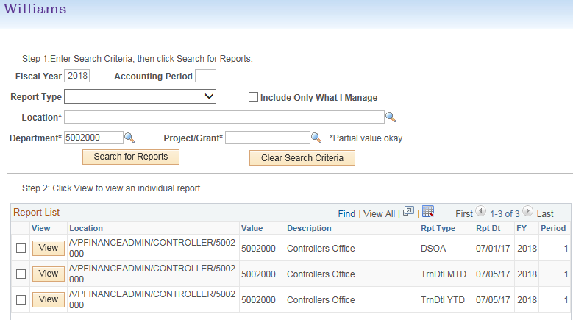

You will see multiple reports.
The first report is usually the summary report which offers a snapshot of all spending for the current Fiscal Year (2018). Sometimes the first report is the miscellaneous report.
Open this report (either a DSOA or a PSOA) depending whether you entered a Project # (PSOA) or Department # (DSOA) by checking the box and selecting “View.”
You can also access transaction detail reports (month-to-date or year-to-date).
If you enter no dept or project numbers, you can usually see the overall summary report for your entire office / department as a whole, with everything on one page. This is the DPSM report (not shown here).

For any technical issues viewing this report, please contact:
Lisa Gazaille - 413-597-4002 Karen Jolin - 413-597-4023

For any budget questions related to this report, please contact:
Kristan Renish – 413-597-4098 Christina Gregory – 413-597-4003

