Journal Entry Creation
Access PeopleSoft Finance. Link can be found on the Controller’s Website on the right panel under PeopleSoft Finance or click here to access.
Login to PeopleSoft Finance and select JEs and AP Forms from the My Williams menu.
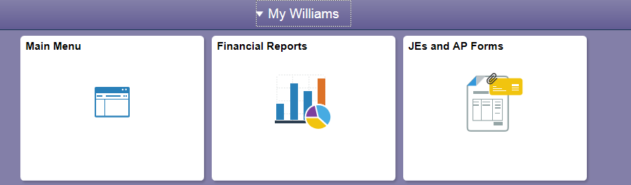
You can also access the Create/Update Journal Entries screen from the Main Menu screen and navigate through the Main Menu drop-down:
The Create/Update Journal Entries page will open on the tab to Add a New Value.
[Refer to Appendix A for information on searching for an existing journal.]
The fields will auto populate with the correct Business Unit, Today’s Date, and the Journal ID of NEXT (PeopleSoft Finance will assign an ID once the journal is saved). Click Add to begin creating the journal entry.
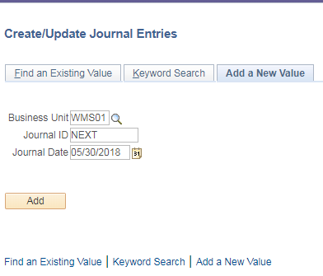

Header Tab: Enter the Long Description of the journal you are posting. Please start with your first initial and last name for reference so we can easily identify who posted the entry. Be specific so approvers and anyone else can understand the purpose of the journal entry.
Click on the Attachments link to upload documents you have as backup for the journal entry you are posting. Click Add Attachments and Browse for the file. Click Upload and OK to attach to the journal entry. Please note only PDF files are acceptable attachments so you may need to print/save your files as PDF documents prior to uploading. Once uploaded the number in parenthesis with update to the number of attachments you uploaded.
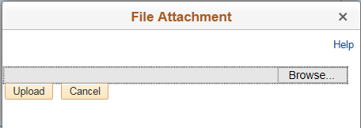

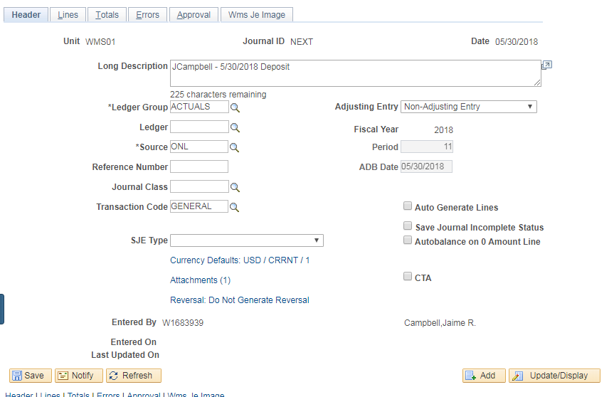

Lines Tab: This is where you will enter the accounting string for your journal entry.
- Account: Enter the PS account number
- Fund: Enter the appropriate fund code
- Dept: Enter department number (not needed if project is entered)
- Project: Enter project code (not needed if department is entered)
- Journal Line Description: This field will auto-populate with the PS account name so please be sure to update the description for each line. There is a 30-character limit so you may have to abbreviate. This field will print on the financial reports.
- Amount: Enter amount as either a debit (positive number) or a credit (negative number using the – sign). Here are some helpful tips for reference:
  - If you are increasing an expense (charging a department/project) you should debit the expense PS account line; credit (negative) if you are reducing the expense (e.g. reversing the expense, recording a refund of an expense, or moving the charge to another department/project)
  - If you are recording revenue (income/sales that came in to your department/project) you would credit the revenue PS account
Once you have entered the first line, click the plus sign box to add another line to the entry. This next line will automatically fill in the fields entered on the line above and the amount will populate with the opposite sign of your entry. Meaning if you entered 1,000.00 on your first line, the amount on the second line will automatically populate as -1,000.00. This is done to ensure the accounting for the journal entry is balanced (more to come on that later).
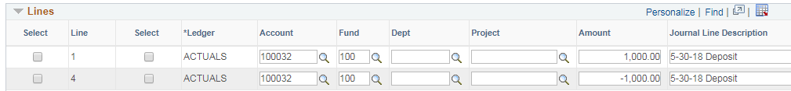

Once you have entered all the lines necessary for your journal entry, click the Save button on the bottom of the screen. This will save the journal and assign a Journal ID (which you will see at the top of the screen) and the Totals section at the bottom will calculate the Total Debits and Total Credits. Review these amounts. In order for a journal entry to post it needs to be balanced, this means the total debits must equal the total credits. If there is an imbalance, correct the amounts as necessary and Save again.
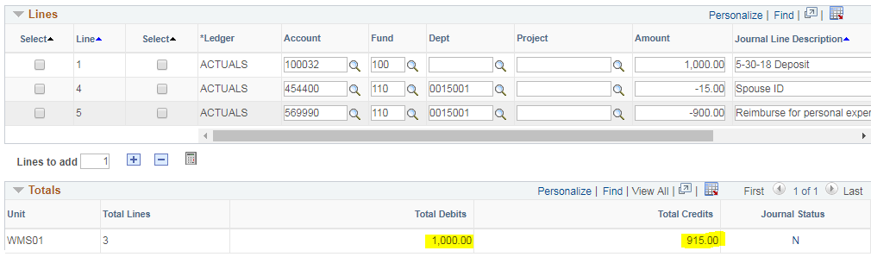

Once Journal is complete, choose Edit Journal from the Process drop-down at the top of the page and click Process. PeopleSoft Finance will review the information entered into the fields and ensure they are correct (e.g. correct fund is used with correct PS account, etc.) and the entry is balanced.

If there are errors with any of the fields the Journal Status will change to E. Click on the E or navigate to the Errors tab to see what the errors are and correct.
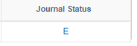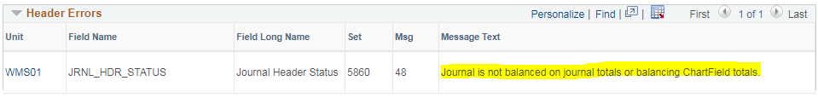

Once corrections are made Edit Journal again.
Journal status will change to V (Valid).
Choose Submit Journal from the Process drop-down and click Process journal. This will alert the Controller’s Office that a journal entry needs to be approved and posted to the General Ledger. When the journal is approved, an automated email will be sent from the approver to you notifying you the journal was posted.

If you want to keep a copy of the journal for your records, choose Print Journal from the Process drop-down and click Submit. A webpage will open for you to save or print the journal entry.

Please contact the Controller’s Office with any questions.

Appendix A: Searching for Existing Journal Entry
To search for an existing journal entry access PeopleSoft Finance and choose JEs and AP Forms from the My Williams page.
Find an Existing Value:
- The Business Unit field is required but will auto-populate (WMS01)
- Enter the Journal ID you are searching for. To search for an ID without the leading zeros select Contains in the drop-down box; and/or
- Search by Journal Date. Use the drop-down box to choose a range, a specific date, etc. Or,
- Your ID number is automatically populated and can’t be removed. The system will only return the journal entries that you created.
- Click Search

