PeopleSoft Financials
Electronic Journal Entry Process

Log into PeopleSoft Finance – UserID = Employee ID number with a leading W.
Password = same password used for all PeopleSoft systems.
Follow the navigation
Main Menu – General Ledger – Journals – Journal Entry – Create/Update Journal Entries
Create the journal entry.
Edit the journal entry – be sure that there are no errors.
Scan all backup and save the backup to a designated folder on your computer.
Attach the scanned backup to the journal entry that you created.
On the Header panel where the long description is entered, there is a link “attachments” found toward the bottom of the page. Click on the word attachments. This will open a window called Journal entry attachments. To attach the backup click on “add attachment” and browse for the document/s. You do have the ability to attach multiple attachments if necessary. Be sure that “show to approver” has a check mark. You can also enter a description. When this screen is completed, click on OK.

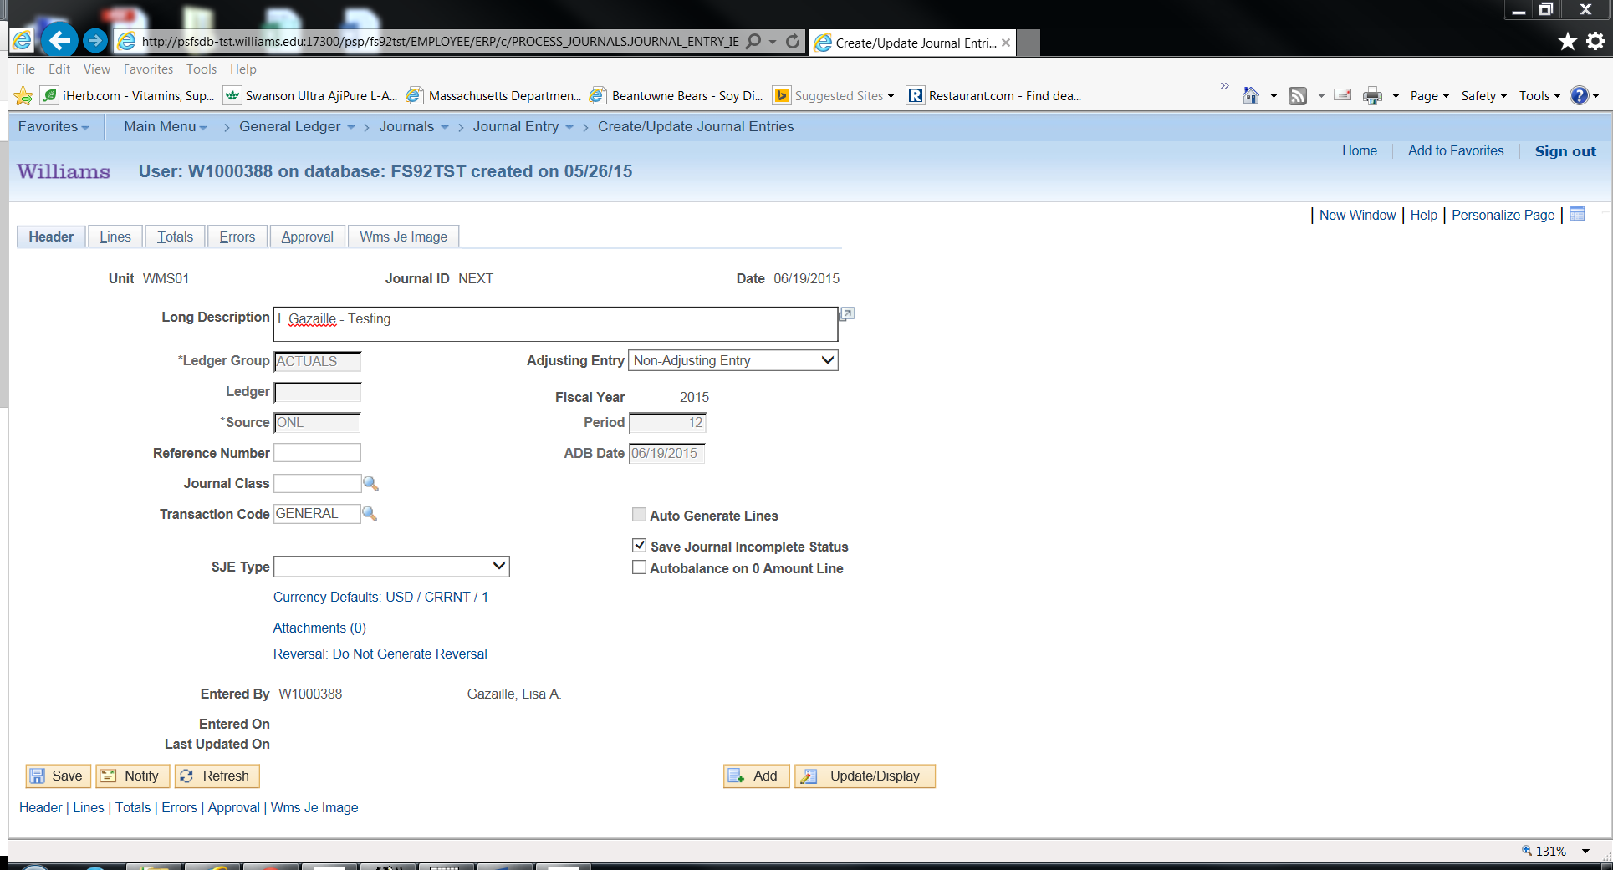

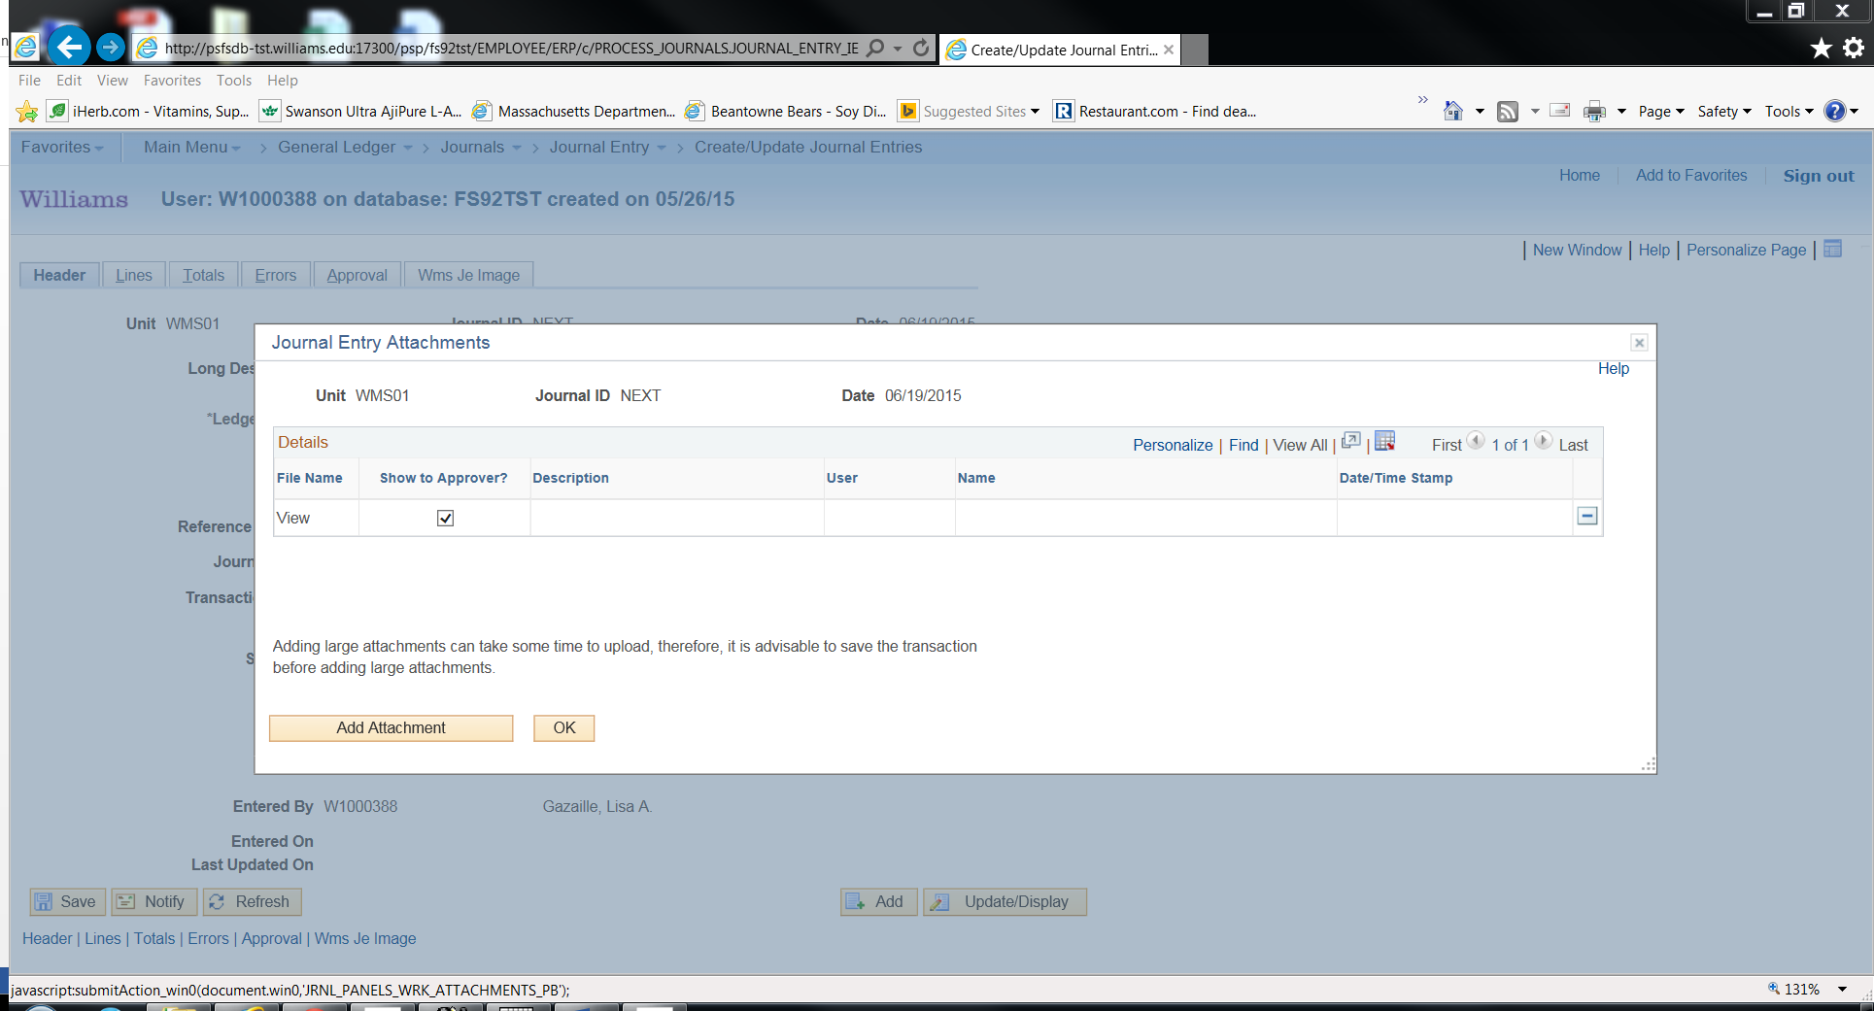

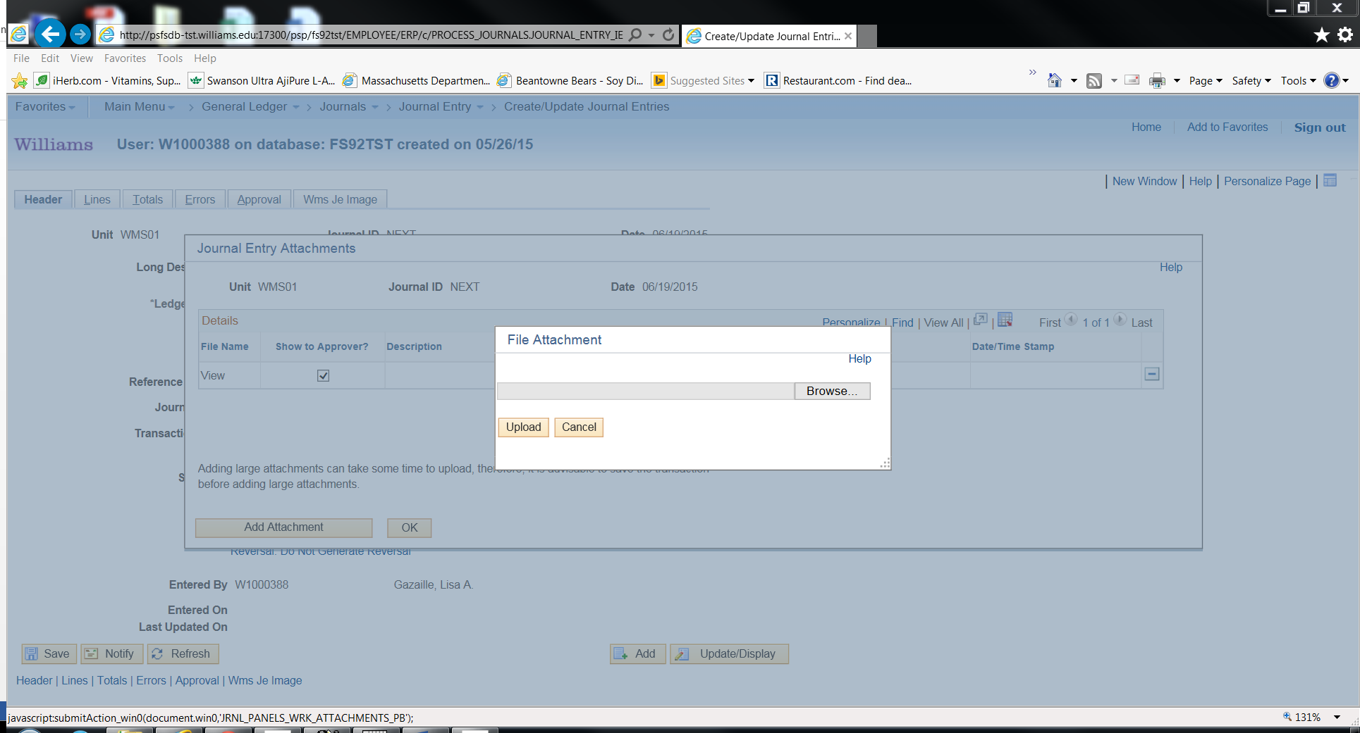

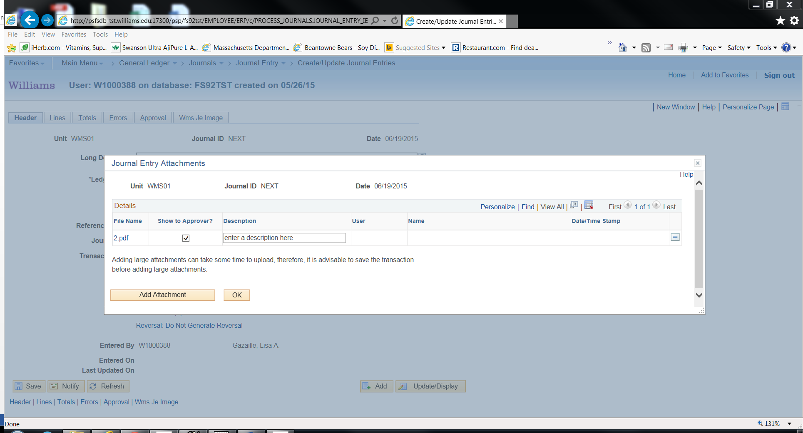

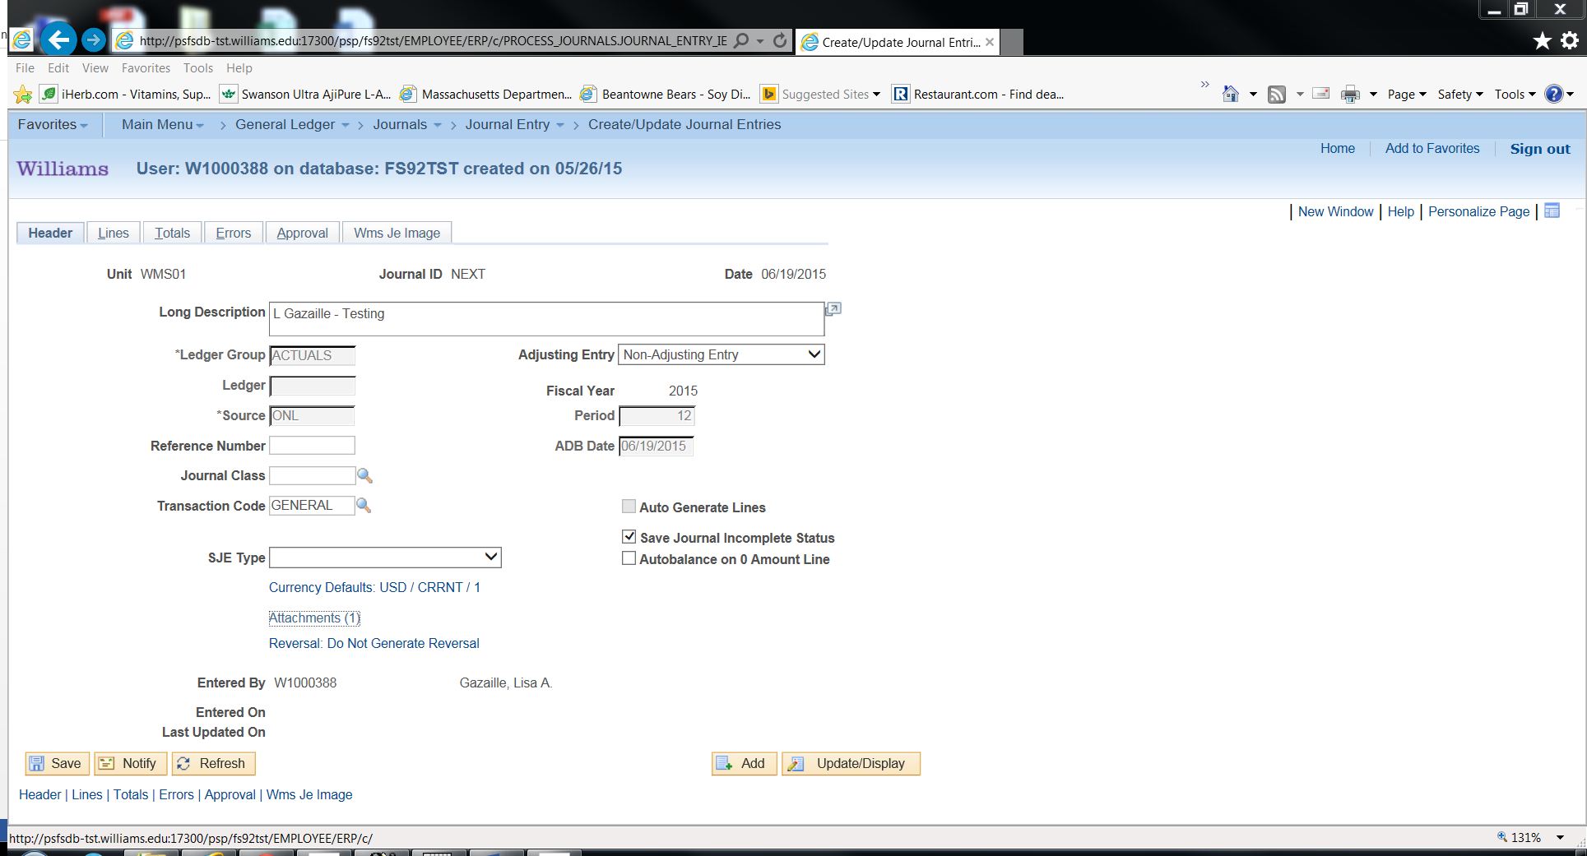

Or you can attach more than one attachment per journal entry.

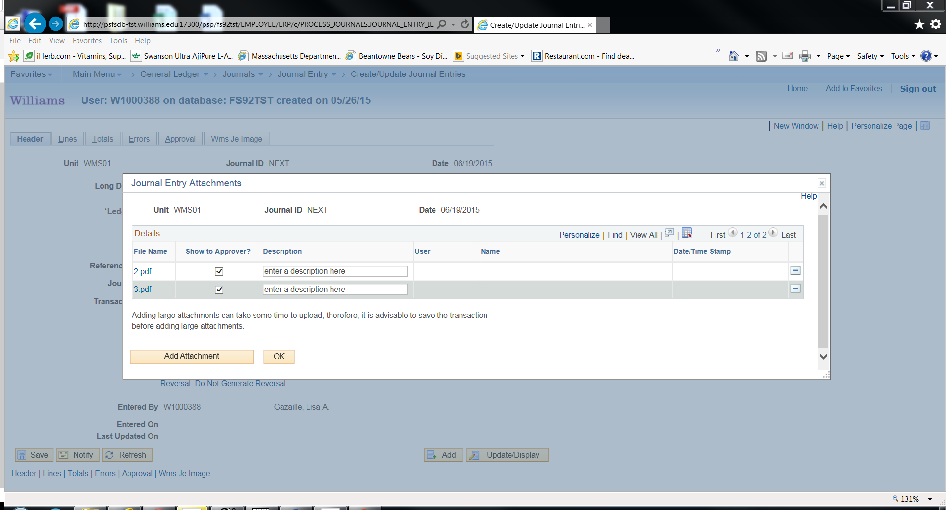

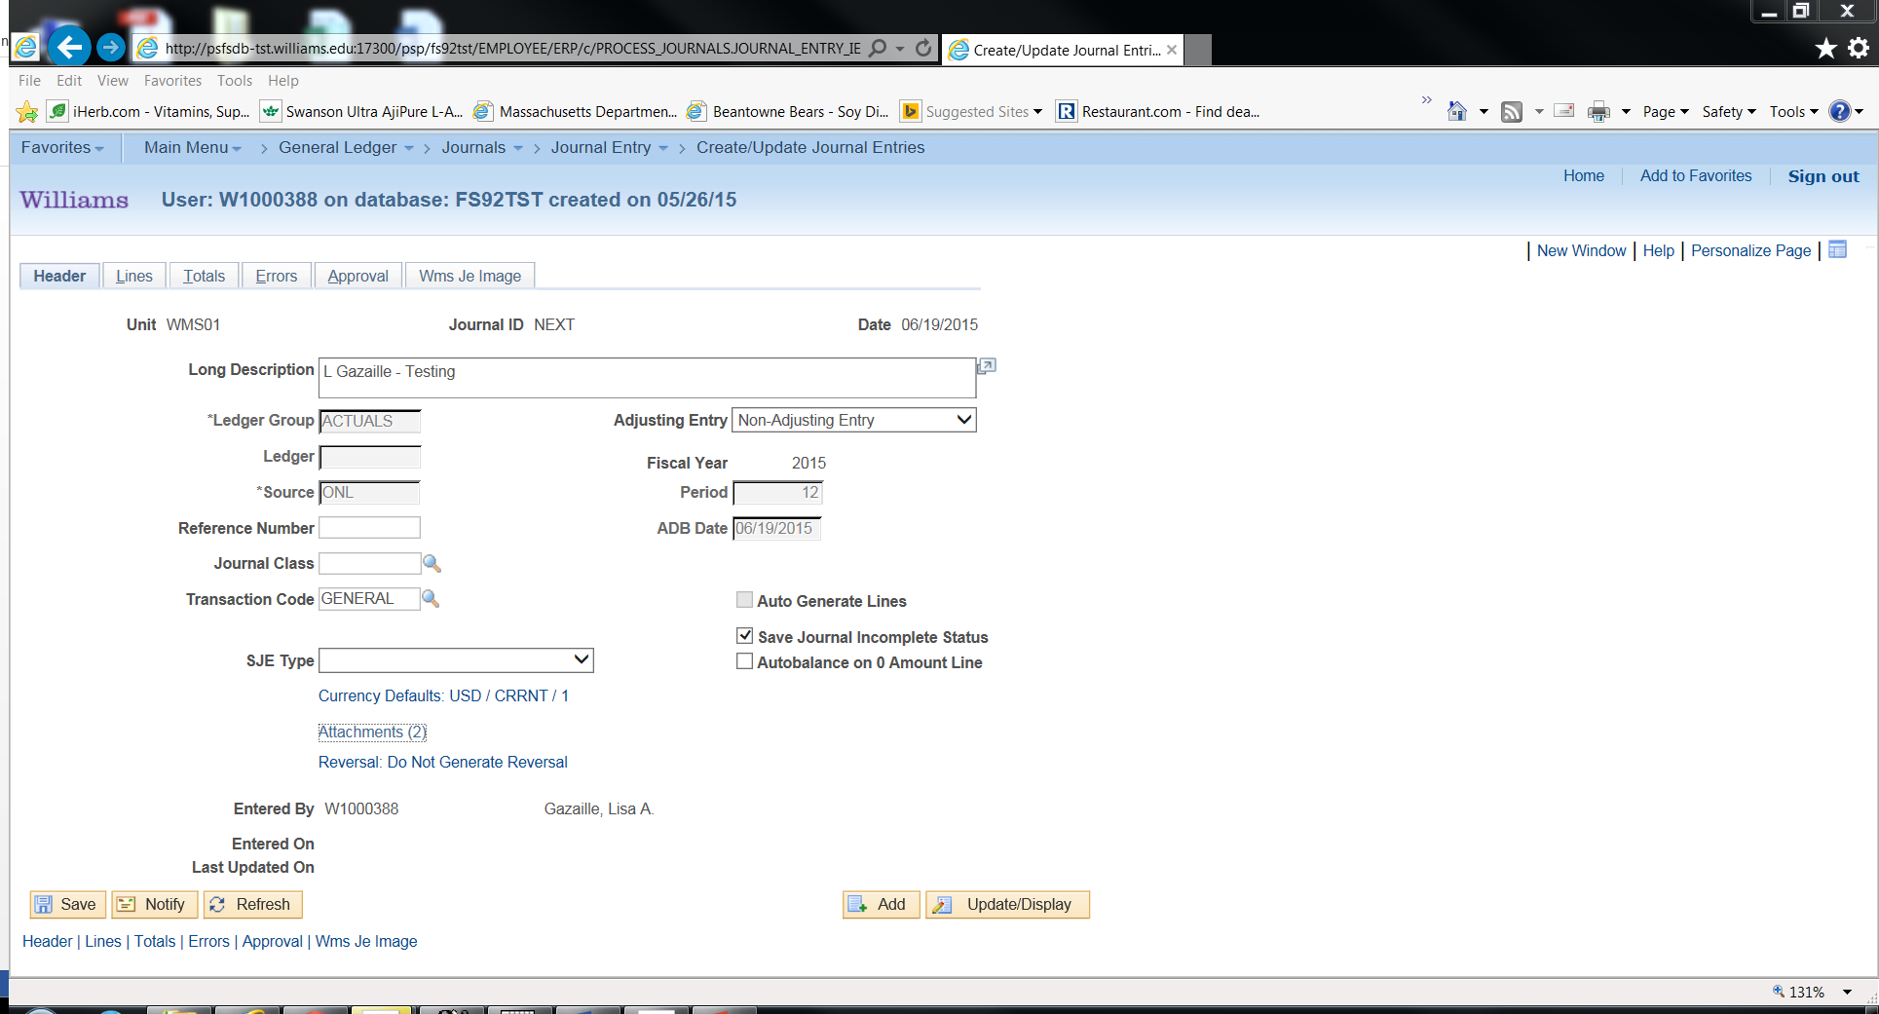

Edit the journal entry can be sure that the status is a V. If the journal entry is in (E) – error status, it will not be electronically submitted.
Select the Submit option from the drop down (same place you go to edit & print). The JE and attachment are electronically sent to the Controller’s Office via workflow.
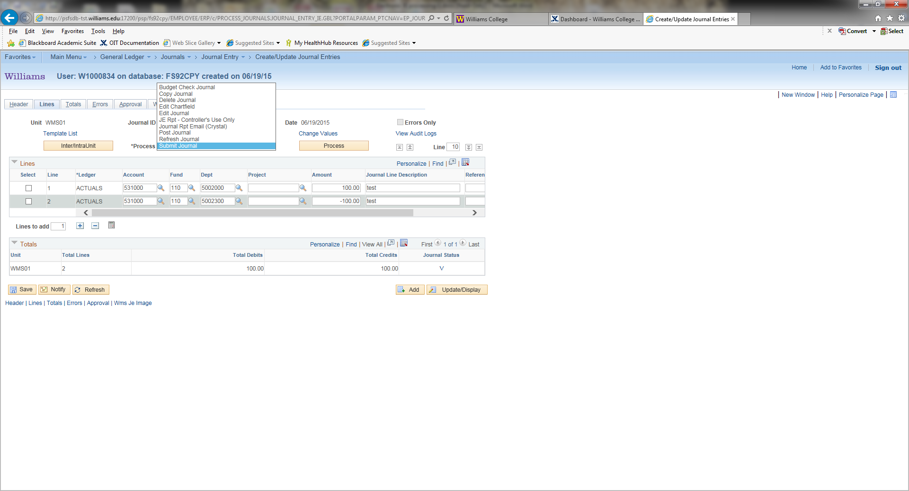

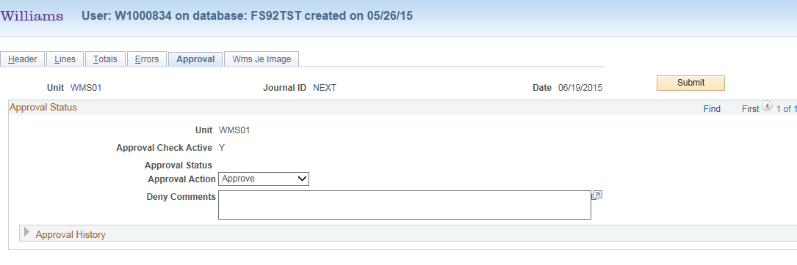

You still have the ability to print a copy or save in a folder on your computer if a copy is needed for your record keeping.

You can also check the status of the approval by going to the “approver tab”

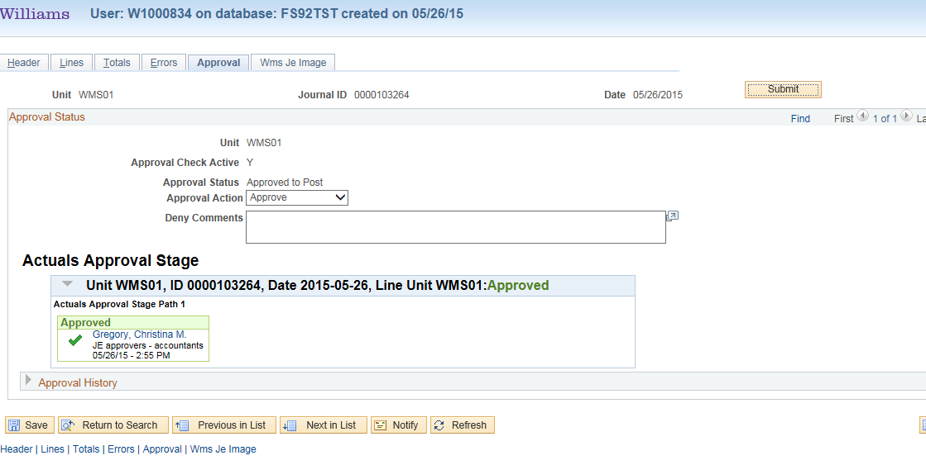

Once approved, you will receive an email saying your Journal Entry has been approved and will be posted. You should see the transactions on your reports the next business day.

